Lab 7
Student ID: 2230006930
Student Name :Maha Faris AlQhtani
Group : 8F-Ai01
Task 1 code screenshot
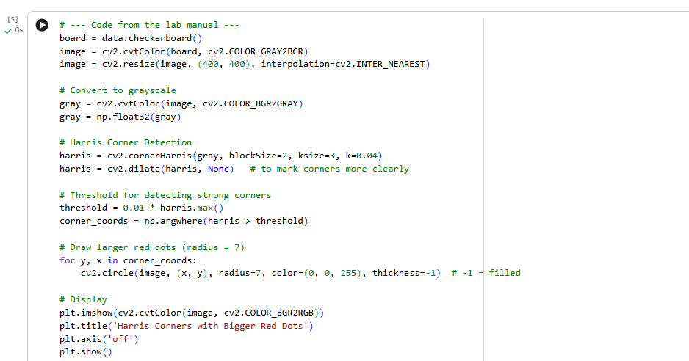
Task 1 output screenshot
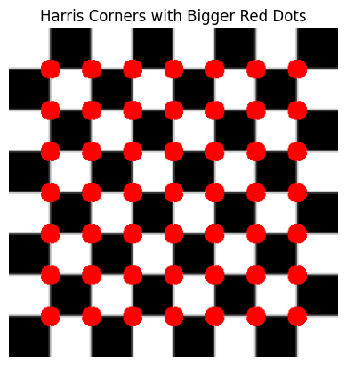
Task 2 code screenshot
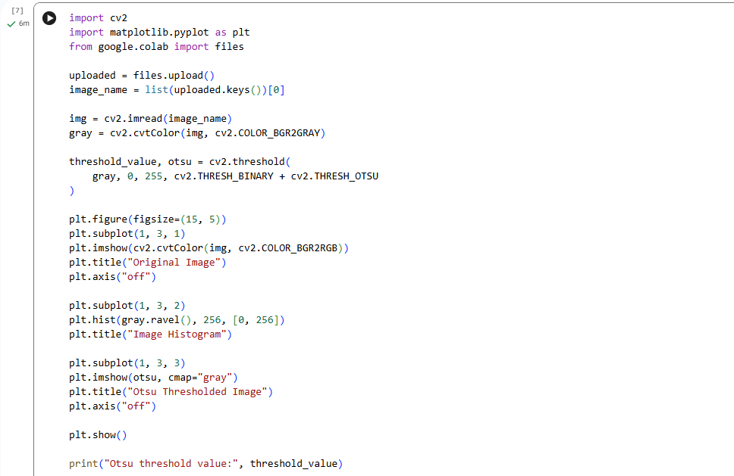
Task 2 output screenshot showing:
original image - Histogram - thresholded image

